**Linear Equations in One Variable**

**LINEAR EQUATIONS IN ONE VARIABLE**

MATHS

1. An equation is a statement of equality of two algebraic expressions involving one or more unknown quantities.
2. An equation involving only a linear polynomial is called a linear equation.

For example:



2x

5

4

1 , 3t t 7

2 2

3

11.

1. Any value of the variable which makes the equation a true statement is called the solution or root of the equation.

For example: - 2 is root of the equation 3x - 2 = -8.

1. Any term of an equation may be taken to the other side with its sign changed, without affecting the equality. This process is called transposition.
2. Without changing the equality, we may
   1. add the same quantity to both sides of the equation.
   2. subtract the same quantity from both sides of the equation.
   3. multiply both sides of the equation by the same non-zero quantity.
   4. divide both sides of the equation by the same non-zero quantity.
3. If

ax b p , then q (ax + b) = p (cx + d)

cx d q

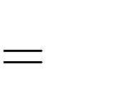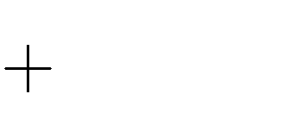

This process is called cross multiplication.